A

Seminar Report On

**Recommendation System Using Machine  Learning**

Submitted

by

### Mr. Aranav Mahalpure

***of T.E. (Computer Engineering- Course 2019) having Examination Seat No.***

***and Roll No. TA66 in partial fulfillment for the award of degree Bachelor of Engineering in Computer Engineering for Academic Year 2023-2024 semester I***

*Under the guidance of*

### Prof. Abhijeet Sagare



**Department of Computer Engineering**

Hope Foundation’s

International Institute of Information Technology, Hinjewadi,

Pune – 411057

**Savitribai Phule Pune University, Pune**

## Hope Foundation's

**International Institute of Information Technology, Pune – 411057**





### Department of Computer Engineering

Certificate

This is to certify that, the Seminar Report entitled **“Recommendation System Using Machine  Learning”** submitted by **Mr. Aranav Mahalpure** of Third Year having Examination Seat No. and Roll No. TA66 is a bonafide work completed under my supervision and guidance in partial fulfillment for award of degree of Bachelor of Engineering in the branch Computer Engineering of International Institute of Information Technology, Hinjewadi, Pune-57.

**Prof. Abhijeet Sagare**

**Seminar Guide**

**Dr.Ajitkumar Shitole Dr. Vaishali V. Patil**

**Head of Department Principal**

## Acknowledgment

I would like to express my special thanks of gratitude to my internal guide Prof. Abhijeet Sagare well as Dr. Ajitkumar Shitole, Head of Department who gave me the golden opportunity to do this seminar on the topic “**Recommendation System Using Machine  Learning**” which also helped me in doing a lot of research and I came to know

About so many new things.

While doing this seminar, I had to take the help and guideline of some respected persons, who deserve our greatest gratitude. The completion of this seminar gives me much Pleasure. I would like to show our gratitude Prof. Abhijeet Sagare, Seminar Coordinator for giving me a good guidelines for seminar throughout numerous consultations. I would also like to expand my deepest gratitude to all those who have directly and indirectly guided me in completing this seminar. Secondly, I would like to thank my friends for helping me with this seminar within the limited time frame.

I also extend sincere thanks to all the staff members of Department of Computer

Engineering and Dr. Vaishali V. Patil, Principal for helping me in various aspects.

#### Mr. ARANAV MAHALPURE

CLASS:- TE(Computer Engineering)

ROLL NO. :- TA66

## Abstract

The rapid growth of e-commerce platforms has led to an overwhelming abundance of products and services, making it increasingly challenging for users to discover items that align with their preferences and needs. To address this issue, our project focuses on the development and implementation of a recommendation system that leverages collaborative filtering and machine learning techniques.

The objective of our recommendation system project is to provide users with personalized product recommendations that enhance their shopping experience, boost user engagement, and increase conversion rates. We achieve this by harnessing collaborative filtering, a widely-used recommendation approach, and integrating it with machine learning algorithms to fine-tune and optimize the recommendations.

Our system collects user behavior data, such as purchase history, product views, and ratings, and employs collaborative filtering methods, including user-based and item-based filtering, to identify patterns and similarities among users and products. These patterns serve as the foundation for generating personalized recommendations. Machine learning models, such as matrix factorization and deep learning, are employed to further refine and enhance the quality of the recommendations.

|  |  |
| --- | --- |
| **Content** | **Page No.** |
| **List of Abbreviations**  **List of Figures**  **List of Graphs/ Tables** | **i**  **ii**  **iii** |
| **1. Introduction** | 1 |
| 1.1 Introduction | 1 |
| 1.2 Objective | 2 |
| **2. Literature Survey** | 3 |
| 2.1 Summary of all pages. | 4 |
| **3 Motivations and Objectives** | 5 |
| * 1. Motivation   2. Proposed Approach | 5  6 |
| **4 Details of design/technology/analytical and/or experimental work** | 7 |
| 4.1 Introduction | 7 |
| 4.2 Architecture | 8 |

1. **Conclusions and Future Work** 
   1. Future Scope 9
   2. Comparison 10
   3. Conclusions 11
2. **References** 12
3. **Annexure I**  13

## List of Abbreviations

1. RS - Recommendation System
2. CF - Collaborative Filtering
3. ML - Machine Learning
4. DL - Deep Learning
5. NLP - Natural Language Processing
6. CB - Content-Based
7. IBCF - Item-Based Collaborative Filtering
8. UBCF - User-Based Collaborative Filtering
9. SVD - Singular Value Decomposition
10. ALS - Alternating Least Squares
11. DNN - Deep Neural Network
12. LSTM - Long Short-Term Memory
13. CNN - Convolutional Neural Network
14. API - Application Programming Interface
15. GUI - Graphical User Interface
16. KNN - k-Nearest Neighbors
17. SVD++ - Singular Value Decomposition with Implicit Feedback
18. RMSE - Root Mean Square Error
19. MAE - Mean Absolute Error
20. MAP - Mean Average Precision
21. CTR - Click-Through Rate
22. IR - Information Retrieval
23. UI/UX - User Interface/User Experience
24. API - Application Programming Interface
25. SQL - Structured Query Language
26. KPI - Key Performance Indicator
27. ROC - Receiver Operating Characteristic
28. AUC - Area Under the Curve
29. JSON - JavaScript Object Notation
30. CSV - Comma-Separated Values
31. HTML - Hypertext Markup Language
32. GPU - Graphics Processing Unit
33. CPU - Central Processing Unit

## List of Figures

1. Fig. 4.2.1 System Architecture

## List of Table/Graphs

* 1. Table 2.1 Summary of Reference Paper
  2. Table. 5.2.1 Comparison

**CHAPTER 1**

# Introduction

* Have you ever Wondered how Youtube recommends content
* How Facebook  recommends you, New Friends?
* Perhabs you’ve noticed similar Recommendation with the Linkedin connection
* How Amazon Recommends the Product while You’re Browsing .

  Answer :-All of these Recommendation are made Possible by the implementation of Recommender system.

**Content-Based  Recommendation Systems.**

Content-based filtering methods are done based on user characteristics. This method is used in situations where data is known on an item such as name, location, or description and not on the user. It predicts the items based on user’s information and completely ignores contributions from other users as with the case of collaborative techniques. It uses the data that is provided by the user either explicitly or implicitly. When the user provides more content-based filtering mechanisms actions on the recommendations such as content-based recommender the engine becomes more and more accurate.

**Collaborative Filtering Recommendation Systems.**

This system identifies users with similar tastes and uses their opinion to recommend the same to another user with similar interest. It generates recommendations using information about rating profiles for different users or items. It has been implemented in different applications such as YouTube, Netflix, and Spotify. It is a widely used approach and is used as a part of the hybrid system.

**Hybrid Approach**

A hybrid approach is a combination of collaborative filtering content-based filtering, or any other approaches. Hybrid approaches can be implemented by making predictions separately on content-based and collaborative-based approach and later combining them. It increases the accuracy and performance of the recommender systems.

### Objectives

1. Improve User Engagement: Enhance user experience by providing personalized recommendations that keep users engaged with the platform or service.
2. Increase User Retention: Encourage users to return to the platform by offering them relevant and appealing recommendations.
3. Boost Conversions: Increase the likelihood of users making purchases or taking desired actions through tailored product or content recommendations.
4. Enhance User Satisfaction: Improve overall user satisfaction by delivering content or products that align with individual preferences and needs.
5. Reduce Information Overload: Help users navigate through the abundance of choices by presenting them with a curated selection of items.
6. Enhance Cross-Selling and Upselling: Suggest related or complementary products or services to increase the average transaction value.
7. Personalize Content Delivery: Tailor content recommendations for media streaming services, news websites, or educational platforms to cater to individual interests.
8. Optimize Search Results: Incorporate recommendation algorithms to improve the relevance of search results, making it easier for users to find what they are looking for.
9. Mitigate Cold Start Problem: Address the challenge of providing recommendations for new users or items with limited historical data.
10. Balance Exploration and Exploitation: Find the right balance between recommending items that users are already familiar with (exploitation) and introducing them to new and diverse items (exploration).
11. Aid Decision-Making: Support users in decision-making processes by offering personalized choices and explanations for recommendations.
12. Increase Click-Through Rates (CTR): Improve the likelihood that users will click on recommended items in emails, websites, or mobile apps.
13. Customize User Interfaces: Personalize the user interface or homepage layout based on user preferences to highlight recommended content.
14. Collect and Analyze User Behavior Data: Continuously gather and analyze user interactions to fine-tune recommendation algorithms and user profiles.
15. Reduce Churn: Retain users by re-engaging them with tailored content or products, especially those at risk of leaving the platform.
16. Enhance Advertising Targeting: Increase the effectiveness of ad campaigns by recommending relevant ads to users based on their preferences.
17. Evaluate Recommendation Algorithms: Measure the performance of recommendation algorithms using relevant evaluation metrics like precision, recall, and click-through rates.
18. Adapt to Seasonal or Trend Changes: Ensure that recommendations adapt to changing user interests and trends over time.
19. Improve Diversity: Balance between popular items and niche recommendations to offer users a diverse range of choices.
20. Monitor and Address Bias: Identify and mitigate bias in recommendations to ensure fairness and prevent discriminatory outcomes.

.

**CHAPTER 2**

# Literature Survey

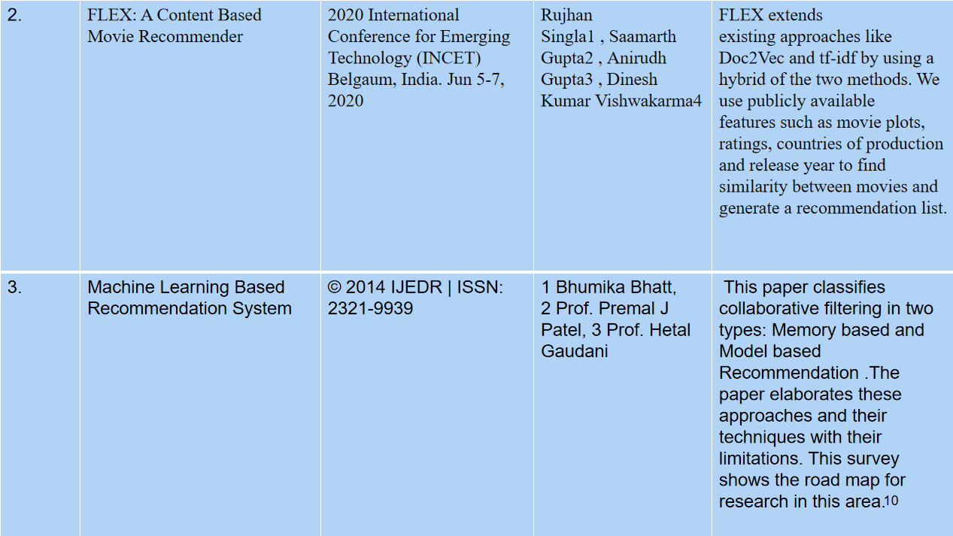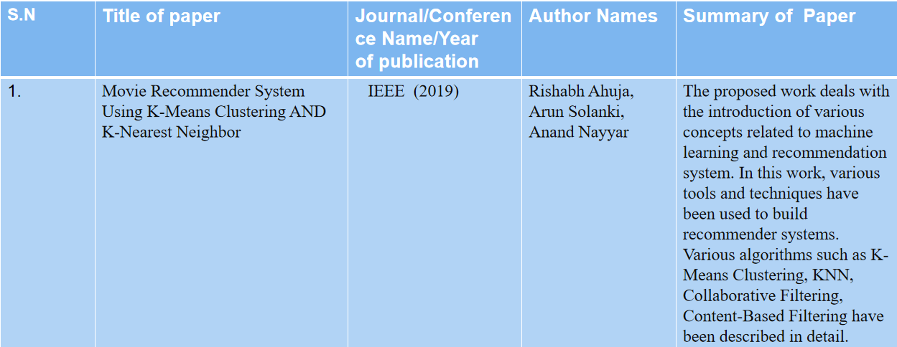Table 2.1 Summary of Reference Paper

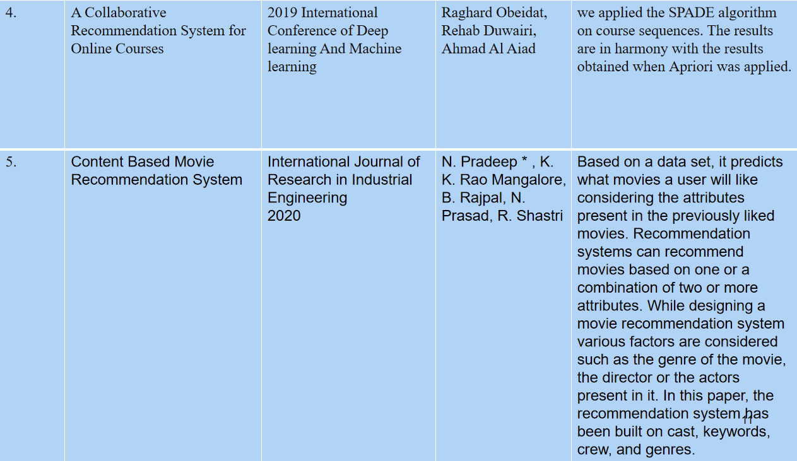

### Summary of all papers

* Collaborative Filtering: Many research papers have explored collaborative filtering techniques, which rely on user-item interactions to make recommendations. Various methods, such as user-based, item-based, and matrix factorization, have been proposed and improved upon. Matrix factorization-based algorithms, like Singular Value Decomposition (SVD) and Alternating Least Squares (ALS), have gained popularity for their ability to handle sparse data.
* Content-Based Filtering: Content-based filtering focuses on using item attributes and user profiles to make recommendations. Research has delved into text analysis and natural language processing (NLP) to extract information from item descriptions and user preferences. Advanced techniques like TF-IDF, Word2Vec, and Doc2Vec have been employed to enhance content-based recommendations. Hybrid Models: Many research papers have proposed hybrid recommendation systems that combine collaborative and content-based filtering techniques.
* Deep Learning: Research has explored the use of neural networks, particularly deep neural networks, to model complex patterns in user behavior and item characteristics. Neural collaborative filtering (NCF), recurrent neural networks (RNNs), and convolutional neural networks (CNNs) have been used for recommendation tasks.
* Implicit Feedback: Traditional recommendation systems mainly relied on explicit user ratings. However, research has shown that implicit feedback, such as clicks, purchases, and browsing history, can be valuable in building effective recommendation models. Matrix factorization and deep learning models have been adapted to handle implicit feedback data.
* Context-Aware Recommendations: Context-aware recommendation systems take into account additional contextual information, such as location, time, and device, to provide personalized suggestions. Research papers have proposed models that incorporate contextual factors into recommendation algorithms.

**CHAPTER 3**

# Motivations and Objectives

* Enhanced User Experience: Recommendation systems can significantly improve the user experience on a website or application by providing personalized content, products, or services. Users are more likely to engage with and continue using a platform that offers tailored recommendations.
* Increased User Engagement: When users discover content or products that align with their preferences, they tend to spend more time on the platform. This increased engagement can lead to higher user retention and customer loyalty.
* Revenue Growth: Recommendation systems can boost sales and revenue by promoting products or services that users are more likely to buy. This is particularly important for e-commerce platforms, where personalized recommendations can lead to increased sales.
* Content Discovery: In content-centric platforms such as streaming services, news websites, or social media, recommendation systems can help users discover new content that they may find interesting but wouldn't have otherwise found on their own.
* Competitive Advantage: Implementing an effective recommendation system can provide a competitive advantage in crowded markets. It can differentiate your platform from others and attract more users.
* Data Utilization: Organizations can leverage the data they collect on user behavior to create value. Recommendation systems are a practical way to make sense of this data and turn it into actionable insights. Personalization: In an era where personalization is highly valued, recommendation systems are essential. They allow you to offer a unique experience to each user based on their preferences, behavior, and history.
* Cross-Selling and Up-Selling: For businesses that offer a range of products or services, recommendation systems can suggest complementary items or premium upgrades, increasing the average transaction value.
* User Retention: Users who receive personalized recommendations are more likely to return to the platform. Retaining users is often more cost-effective than acquiring new ones.
* Data Monetization: In addition to improving user experience, recommendation systems can also become a source of revenue by providing recommendations to third-party advertisers or partners.
* Content Curation: For media platforms, such as news websites or social networks, recommendation systems can help curate and filter content, ensuring that users see content that is relevant and interesting to them.
* Research and Development: Developing recommendation systems involves working with cutting-edge technologies, machine learning algorithms, and data analysis. It can serve as a valuable research project for academia or industry.

**Proposed Approach**

* **Data Collection:** Gather a diverse and comprehensive dataset of movies, including attributes such as movie titles, genres, release years, ratings, user reviews, and tags. Popular sources for movie data include IMDb, TMDb, and MovieLens.
* **Data Preprocessing:** Clean and preprocess the data by handling missing values, standardizing genres, and creating user-item interaction matrices. You may also want to handle outliers and anomalies.
* 3. **Content-Based Filtering:** Utilize content-based filtering to recommend movies based on their attributes, such as genre, director, or actor. Create feature vectors for movies and users, and use similarity measures (e.g., cosine similarity) to suggest movies similar to those a user has liked.
* 4. **Collaborative Filtering:** Implement collaborative filtering methods, including user-based and item-based approaches. These algorithms leverage user-item interaction data to identify similar users or items and make recommendations based on their behavior.
* 5. **Hybrid Approaches:** Combine content-based and collaborative filtering techniques to leverage the strengths of both. Hybrid recommendation systems often provide more accurate and diverse recommendations.
* 6. **Matrix Factorization:** Implement matrix factorization techniques such as Singular Value Decomposition (SVD) or matrix factorization using techniques like Alternating Least Squares (ALS). These can capture latent factors in the data and improve recommendation quality.
* 7. **Deep Learning Models:** Experiment with deep learning models like neural collaborative filtering, which use neural networks to learn complex user-item interactions and provide more accurate recommendations.
* 8. **Evaluation Metrics:** Choose appropriate evaluation metrics, such as Mean Absolute Error (MAE), Root Mean Square Error (RMSE), or precision and recall, to assess the performance of the recommendation system. Cross-validation and A/B testing can help validate the system's accuracy.
* 9. **User Interface:** Develop a user-friendly interface where users can input their preferences and receive movie recommendations. This interface can be a website, mobile app, or integration into an existing platform.
* 10. **Scalability and Real-Time Updates:** Ensure the recommendation system is scalable and capable of handling a growing user base and movie catalog. Consider implementing real-time updates to adapt to changing user preferences and new movie releases.
* 11. **Privacy and Security:** Implement privacy measures to protect user data and comply with data protection regulations. Techniques like differential privacy can be employed to anonymize user information.
* 12. **Deployment:** Deploy the recommendation system to a production environment, whether in the cloud or on-premises, and monitor its performance. Continuously update the recommendation model as new data becomes available.
* 13. **User Feedback Loop:** Encourage users to provide feedback on recommendations to improve the system's accuracy and user satisfaction over time.
* 14. **Optimization and Tuning**: Continuously fine-tune the recommendation algorithms and parameters to optimize the system's performance.
* 15. **Maintenance and Updates:** Regularly maintain and update the recommendation system to keep it up to date with evolving user preferences and movie data.

**CHAPTER 4**

# Details of Design/Technology/Analytical and/or Experimental Work

### Introduction

* Have you ever Wondered how Youtube recommends content
* How Facebook  recommends you, New Friends?
* Perhabs you’ve noticed similar Recommendation with the Linkedin connection
* How Amazon Recommends the Product while You’re Browsing .

  Answer :-All of these Recommendation are made Possible by the implementation of Recommender system.

**Content-Based  Recommendation Systems.**

Content-based filtering methods are done based on user characteristics. This method is used in situations where data is known on an item such as name, location, or description and not on the user. It predicts the items based on user’s information and completely ignores contributions from other users as with the case of collaborative techniques. It uses the data that is provided by the user either explicitly or implicitly. When the user provides more content-based filtering mechanisms actions on the recommendations such as content-based recommender the engine becomes more and more accurate.

**Collaborative Filtering Recommendation Systems.**

This system identifies users with similar tastes and uses their opinion to recommend the same to another user with similar interest. It generates recommendations using information about rating profiles for different users or items. It has been implemented in different applications such as YouTube, Netflix, and Spotify. It is a widely used approach and is used as a part of the hybrid system.

**Hybrid Approach**

A hybrid approach is a combination of collaborative filtering content-based filtering, or any other approaches. Hybrid approaches can be implemented by making predictions separately on content-based and collaborative-based approach and later combining them. It increases the accuracy and performance of the recommender systems.

### 

### Architecture

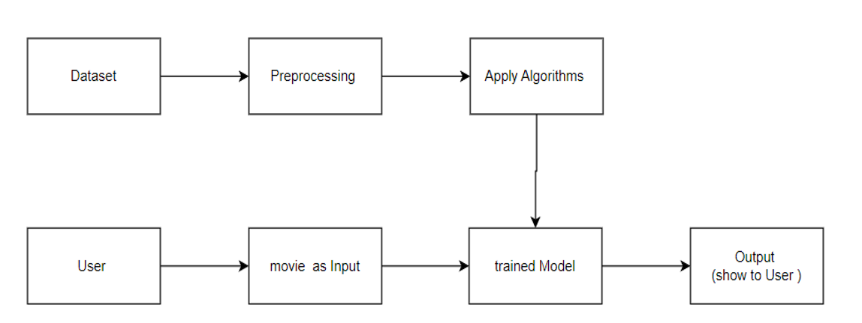

Fig. 4.2.1 architecture of System

**CHAPTER 5**

# Conclusions and Future Work

### 5.1 Future Scope

* **Personalization at Scale:** Future recommendation systems will continue to improve their ability to provide highly personalized content, products, and services to individual users. This personalization will extend across various domains, including e-commerce, streaming, news, and social media.
* **Multi-Modal Recommendations:** Recommendation systems will become more sophisticated in handling multi-modal data, which includes text, images, audio, and video. They will offer recommendations based on user interactions with different types of content.
* **Cross-Platform Recommendations:** Recommendation systems will evolve to provide seamless and consistent recommendations across multiple devices and platforms, ensuring a cohesive user experience whether on a website, mobile app, smart TV, or wearable device
* **Explainable AI:** As the need for transparency and trust in AI systems grows, future recommendation systems will focus on explainability, providing users with clear and interpretable explanations for their recommendations. This is especially important in critical domains like healthcare and finance.
* **Context-Aware Recommendations:** Recommendation systems will increasingly consider the contextual information in which a user is operating. This could include location, time of day, device, social context, and more, resulting in more relevant and timely recommendations.
* **Real-Time Recommendations:** Future systems will work in real-time, adapting recommendations based on a user's behavior and preferences as they evolve. This will be particularly important in fast-paced environments like online gaming or financial trading.
* **Integration with Voice and Conversational Interfaces:** As voice assistants and chatbots become more prevalent, recommendation systems will be integrated with these interfaces to provide recommendations through natural language conversations.
* **Ethical and Responsible AI:** There will be a growing emphasis on building recommendation systems that respect user privacy, avoid bias, and adhere to ethical principles. Regulations and guidelines related to AI ethics will shape the future of these systems.
* **Content Creation Assistance**: Recommendation systems may expand their role in content creation by suggesting topics, keywords, or even generating content. This is relevant in journalism, marketing, and creative fields.
* **Global and Multilingual Recommendations:** Expanding recommendation systems to work effectively in multiple languages and across diverse cultural contexts will be an important area of development as platforms become increasingly global.luding developers and organizations with varying levels of expertise.

### 5.2 Comparing Content Based Filtering Vs Collaborative Based Filtering

### Comparison-types-of-classical-recommendation-systems (1)

Table 5.2.1 Comparison

### 5.3 Conclusion

* **Recap of Objectives:** Begin by restating the primary objectives of the project. What were you trying to achieve with your recommendation system?
* **Methodology Overview:** Briefly summarize the methodologies and algorithms used in the recommendation system, such as collaborative filtering, content-based filtering, or hybrid approaches. Highlight any unique aspects or innovations in your approach.
* **Data and Preprocessing:** Mention the data sources you used and any preprocessing steps undertaken, including data cleaning, feature engineering, and data transformation.
* **Model Performance:** Discuss the performance of your recommendation system. Include metrics like accuracy, precision, recall, F1-score, or Mean Average Precision (MAP) depending on the nature of your project. Compare the performance of different models if you experimented with multiple.
* **Evaluation and Validation:** Explain how you evaluated the recommendation system. Discuss the validation and cross-validation techniques used to ensure the model's generalizability.
* **User Feedback (if applicable):** If you conducted user testing or collected feedback from real users, summarize the key takeaways and insights gained from this feedback.
* **Potential Improvements:** Suggest areas for improvement in your recommendation system. Are there ways to enhance its accuracy, scalability, or user experience?
* **Business Impact:** Discuss the potential business impact of your recommendation system. How can it benefit the organization or users? Quantify this impact if possible.
* **Ethical Considerations:** If relevant, address any ethical considerations, such as bias, fairness, privacy, or transparency, and how you mitigated them during the project.
* **Future Work:** Highlight opportunities for future work and research in the field of recommendation systems. Are there new algorithms, data sources, or technologies that could be explored?

**CHAPTER 6**

# References

* Balabanovic. An adaptive web page recommendation ´ service. In Proceedings of the first international conference on Autonomous agents, pages 378–385. ACM, 1997.
* M. Balabanovic and Y. Shoham. Fab: content-based, col- ´ laborative recommendation. Communications of the ACM, 40(3):66–72, 1997.
* J.S. Breese, D. Heckerman, and C. Kadie. Empirical analysis of predictive algorithms for collaborative filtering. In Proceedings of the Fourteenth conference on Uncertainty in artificial intelligence, pages 43–52. Morgan Kaufmann Publishers Inc., 1998.
* K. Goldberg, T. Roeder, D. Gupta, and C. Perkins. Eigentaste: A constant time collaborative filtering algorithm. Information Retrieval, 4(2):133–151, 2001.
* Sajal. Halder, Md. Samiullah, A. M. Jehad Sarkar, and YoungKoo Lee. Movieswarm: Information mining technique for movie recommendation system. In Submission.
* G. Lekakos and P. Caravelas. A hybrid approach for movie recommendation. Multimedia tools and applications, 36(1):55–70, 2008.
* Z. Li, B. Ding, J. Han, and R. Kays. Swarm: Mining relaxed temporal moving object clusters. Proceedings of the VLDB Endowment, 3(1-2):723–734, 2010.
* G. Linden, B. Smith, and J. York. Amazon. com recommendations: Item-to-item collaborative filtering. Internet Computing, IEEE, 7(1):76–80, 2003.
* B.N. Miller, I. Albert, S.K. Lam, J.A. Konstan, and J. Riedl. Movielens unplugged: experiences with an occasionally connected recommender system. In Proceedings of the 8th international conference on Intelligent user interfaces, pages 263–266. ACM, 2003.
* M. Pazzani and D. Billsus. Learning and revising user profiles: The identification of interesting web sites. Machine learning, 27(3):313–331, 1997.
* P. Resnick, N. Iacovou, M. Suchak, P. Bergstrom, and J. Riedl. Grouplens: an open architecture for collaborative filtering of netnews. In Proceedings of the 1994 ACM conference on Computer supported cooperative work, pages 175–186. ACM, 1994.
* Badrul M. Sarwar, George Karypis, Joseph Konstan, and John Reidl. Recommender systems for large-scale e-commerce: Scalable neighborhood formation using clustering. In Proceedings of the 5th International Conference on Computer and Information Technology (ICCIT), 2002.
* B. Smyth and P. Cotter. A personalized television listings service. Communications of the ACM, 43(8):107–111, 2000.

**CHAPTER 7**

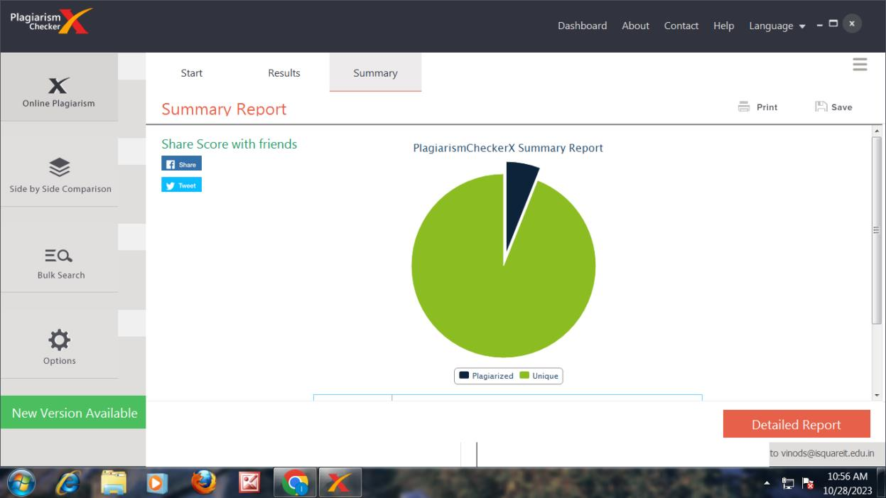**Annexure 1 Plagiarism Check Report**